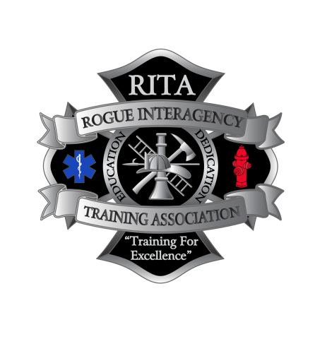

**Fire Officer 3/4**

**Fire Officer 4**

**Feb. 19th - Feb. 22nd**

**JCFD 3**

**8383 Agate Rd., White City OR**

**Fire Officer 3**

**Jan. 29th - Feb. 1st**

**Medford Fire Station 14**

**2208 Table Rock Rd., Medford OR**

**Monday - Thursday 8:00am-6:00pm**

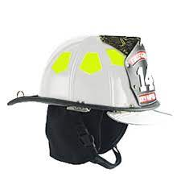

**Course Objective**: To provide students with the knowledge, skills, and abilities necessary to address the administrative and operational challenges of the fire service in the 21st century. Upon successful completion of this course, the student will be able to function as a participant in the day-to-day administrative/ operationally focused process of fire service organizational activities, including human resources management, community outreach programming, budgeting, inspections/pre-incident planning, safety program development, in-basket assessment, and incident planning with multi-agency involvement.

**Registration will be for both classes only.**

**Skills taught**:

* Personnel hiring, evaluations, and assignments
* Risk reduction programs
* Records and resource management
* Inspection program evaluation
* IAP development
* Health & safety program management
* Community demographics
* Setting goals
* Community engagement & involvement
* Long range plan development
* Training resource evaluation & planning
* Risk, hazard, and value analysis
* Comprehensive planning

**Includes:**

* Tuition and Books covered by DPSST
* Light Refreshments and Lunches

**Total Cost for both weeks: $280**

**PREREQUISITE**

**Fire Officer 2**

**For questions contact** [**marshall.rasor@ashland.or.us**](mailto:marshall.rasor@ashland.or.us) **, Chris Howard, MFD,**

**Register online @ orrita.com**