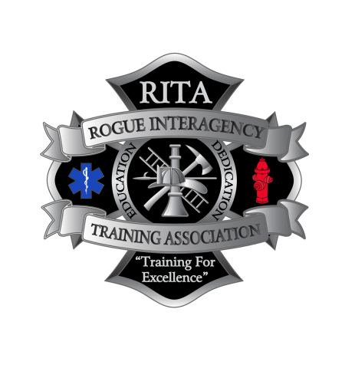

**June 7th, 2025**

**8am-5pm**

**Cost: $10.00**

**Applegate Valley Fire District**

**1095 Upper Applegate Rd., Jacksonville, OR 97530**

This course is designed to produce student proficiency in the performance of duties associated with the **Wildland Firefighter Type 1** position from initial dispatch through demobilization to the home unit.

The NWCG S-131 Firefighter Type 1 course is a training program designed to equip individuals with the knowledge and skills needed to lead small wildland fire teams and operate as a Firefighter Type 1 or Incident Commander Type 5. It focuses on operational leadership, communication, safety procedures, and tactical decision-making.

Students need to be affiliated with an organization that is DPSST certified.

**NWCG S-131**

**(Firefighter Type 1)**

**Register online @ orrita.com**

**Contact: Mitch Kuntz, Class Coordinator,** [**MitchK@applegatefd.com**](mailto:MitchK@applegatefd.com)

**(541) 660-191**